



|  |
| --- |
| **Jasmine Mini 1.01.26.07.2024**  Prompt Test model: Jasmine Mini 1.01.26.07.2024  Aditya Vardhan Chenna |

**Introduction:**

I’m **Aditya Vardhan Chenna**, the creator of **Jasmine Mini**, a cutting-edge LLM GenAI model.

**Jasmine Mini** represents a significant milestone in my journey to push the boundaries of AI technology. I’m excited to continue refining and evolving this model to unlock new possibilities and applications.

NOTE: This notebook uses the **PaLM** generative model, which will reach its discontinuation in October 2024, The latest **Gemini** model will be implemented in the next update.

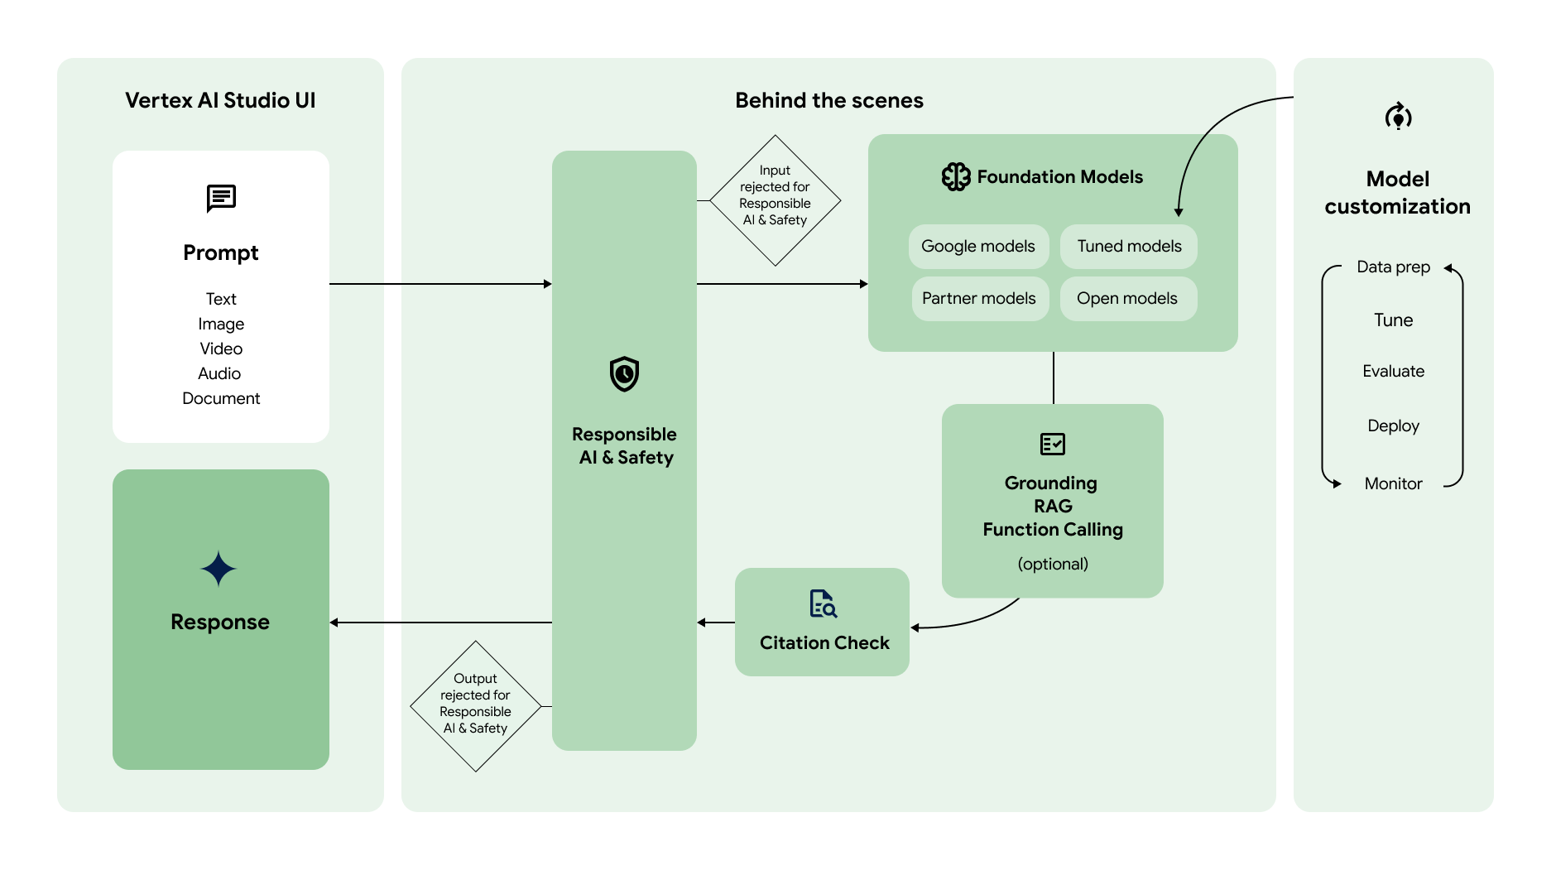

You can use the next couple of paragraphs to provide more newsworthy information. Include secondary details and even previous announcements to provide more context on this event.

**Objective:**

I developed Jasmine Mini using Vertex AI GenAI software from the Google Cloud Platform (GCP). This project utilizes GCP’s advanced tools and infrastructure to build a sophisticated LLM model focused on enhancing natural language processing.

To achieve high-quality, contextually accurate AI interactions, I implemented the following practices:

• Ensured concise communication

• Maintain specificity and clear definitions

• Address one task at a time

• Transform generative tasks into classification tasks

• Enhance response quality by incorporating examples

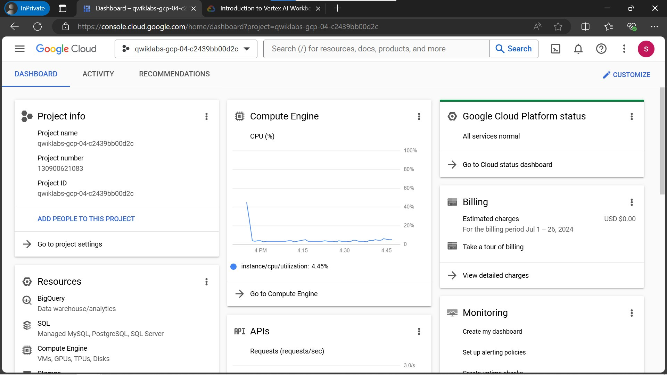

Add a caption here

**Credits:**

With the Help of **Vertex AI GenAI Studio.** This prompt design uses billable components of Google Cloud:

• Vertex AI Generative AI Studio

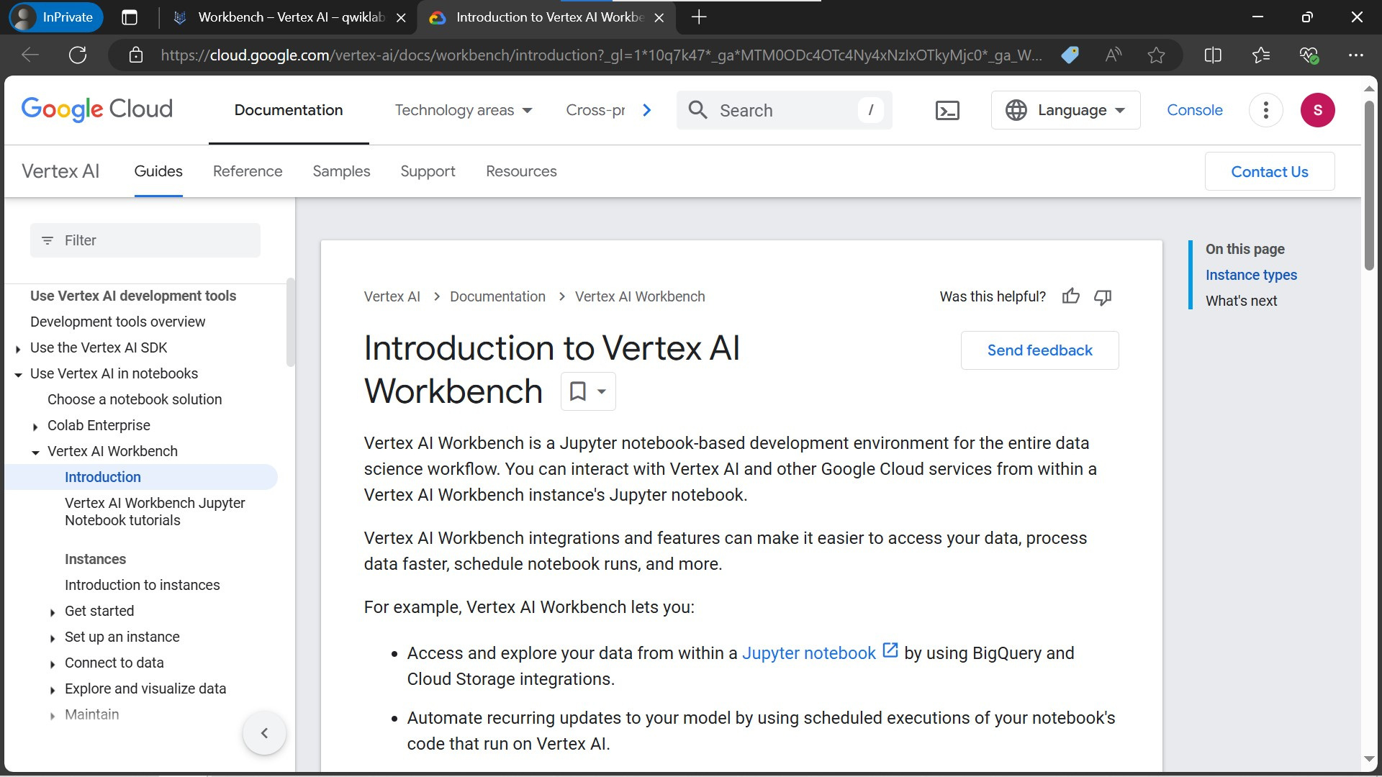

|  |  |
| --- | --- |
| **Prompts as I/P for Jasmine** |  |

*Here are some of the prompts that I gave as input to Jasmine Mini and the output follows:*

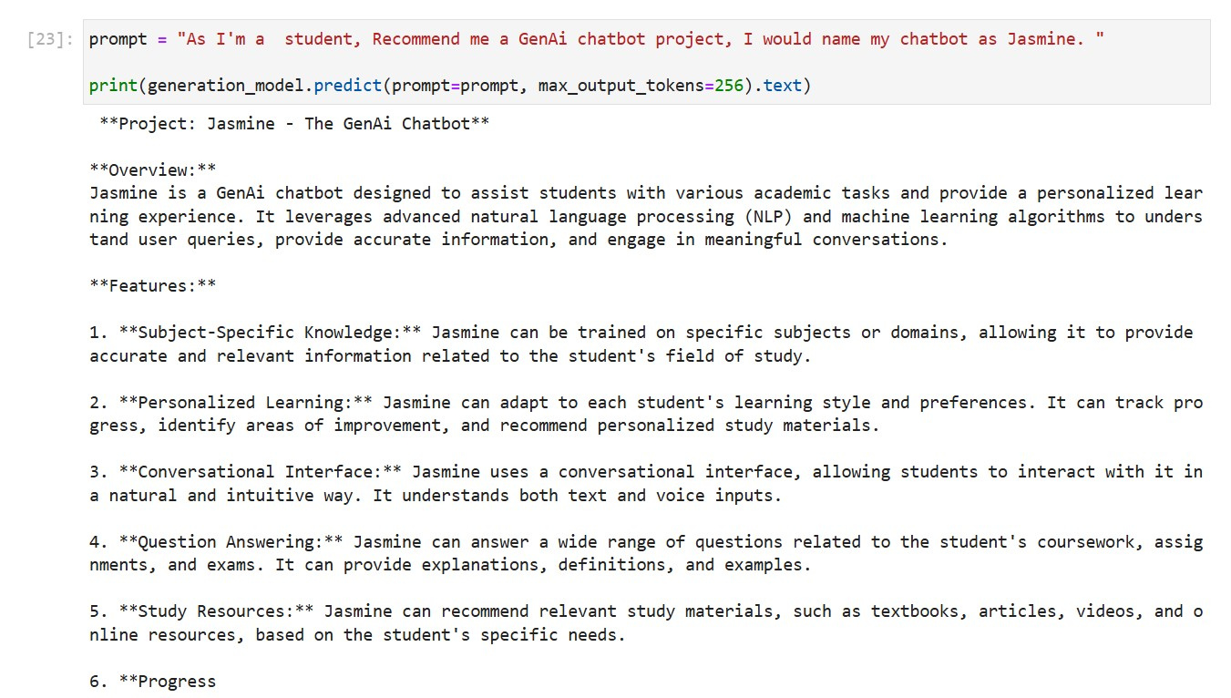

|  |  |
| --- | --- |
| **Jasmine for Earth** |  |

***Prompt: “You know what, I love Earth, How can I care this lovely blue-green ball.”***

***Output:***

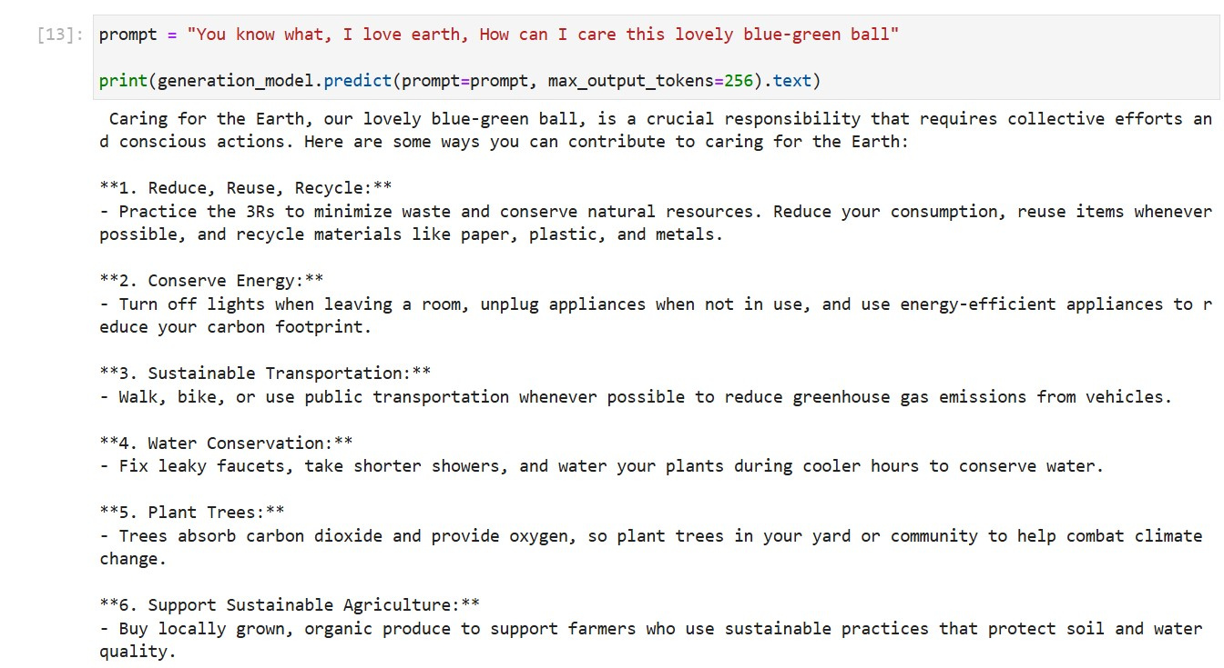

***Prompt: “Does Earth love humans? Or Humans love Earth?”***

***Output:***

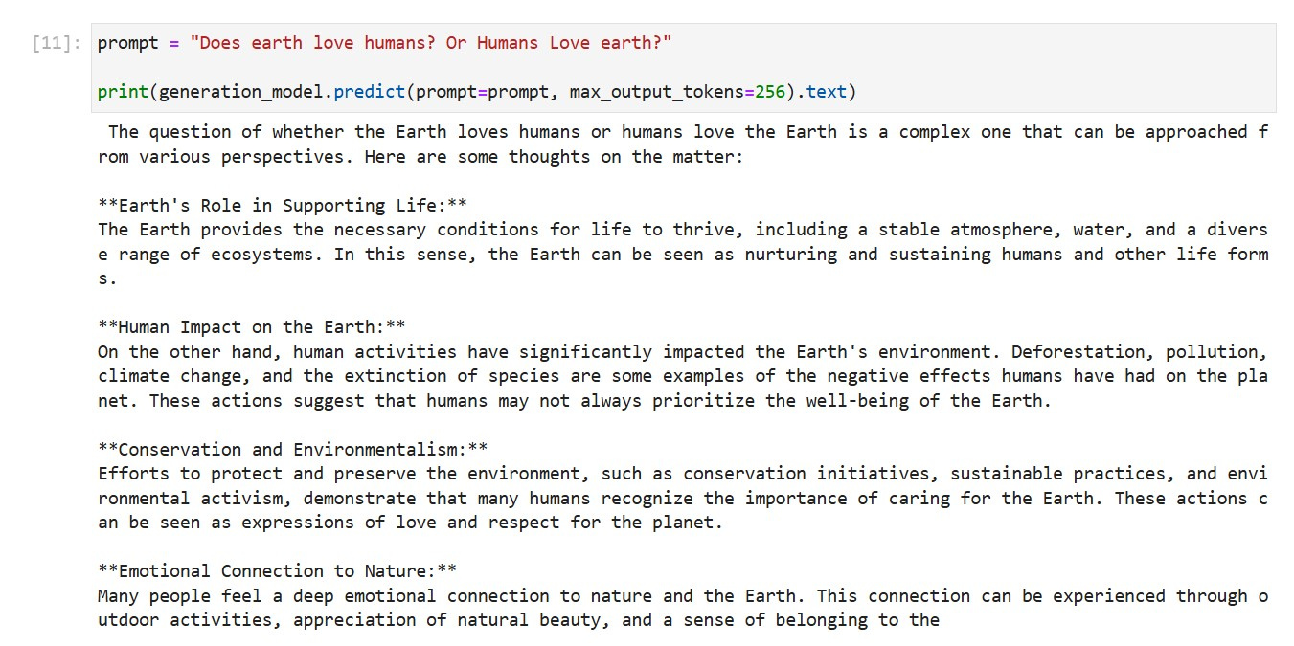

***Prompt: “Generate a list of ways that makes Earth unique compared to other planets.”***

***Output:***

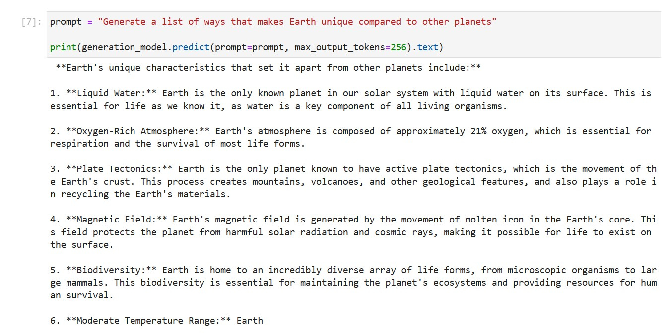

|  |  |
| --- | --- |
| **Will AI protect Earth?** |  |

***Prompt: “Since the next Super boom is AI, will AI protect Earth?”***

***Output:***

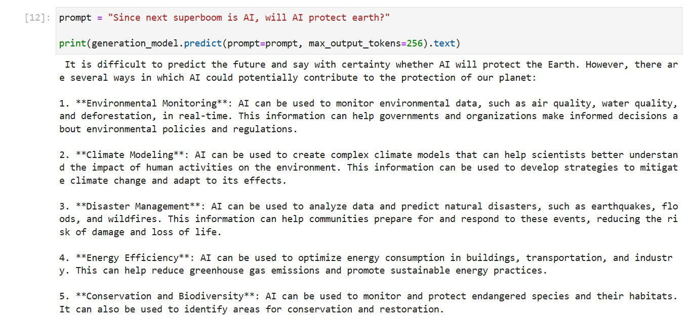

|  |  |
| --- | --- |
| **The Vertex API** |  |

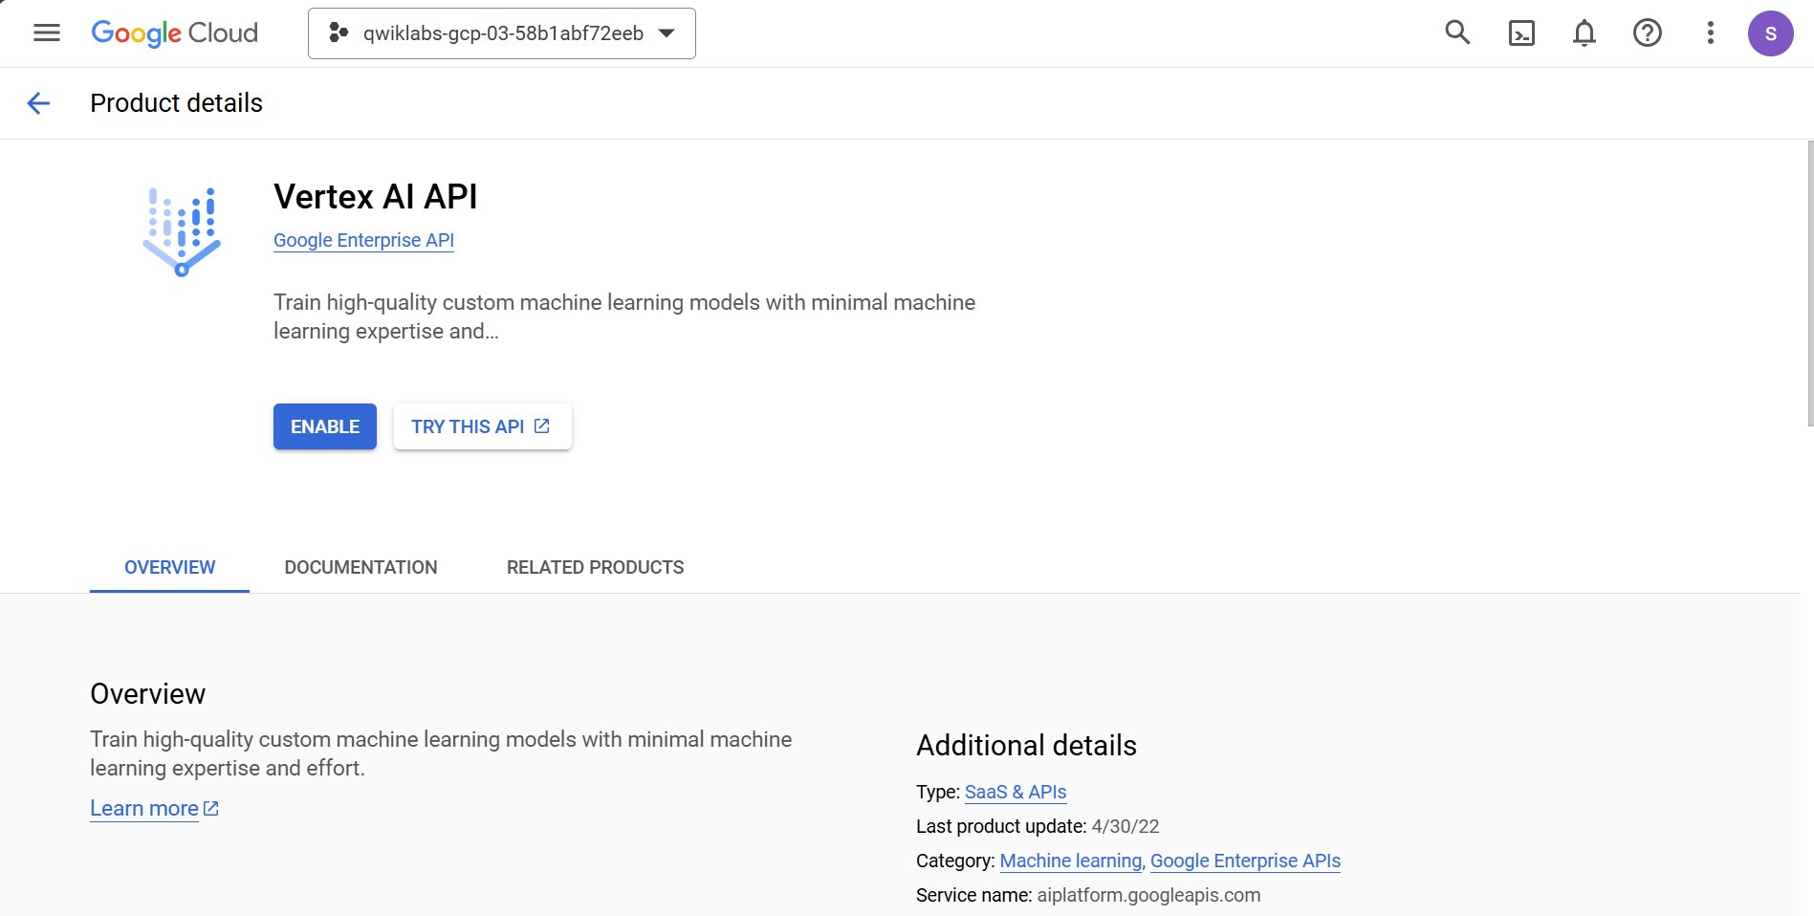

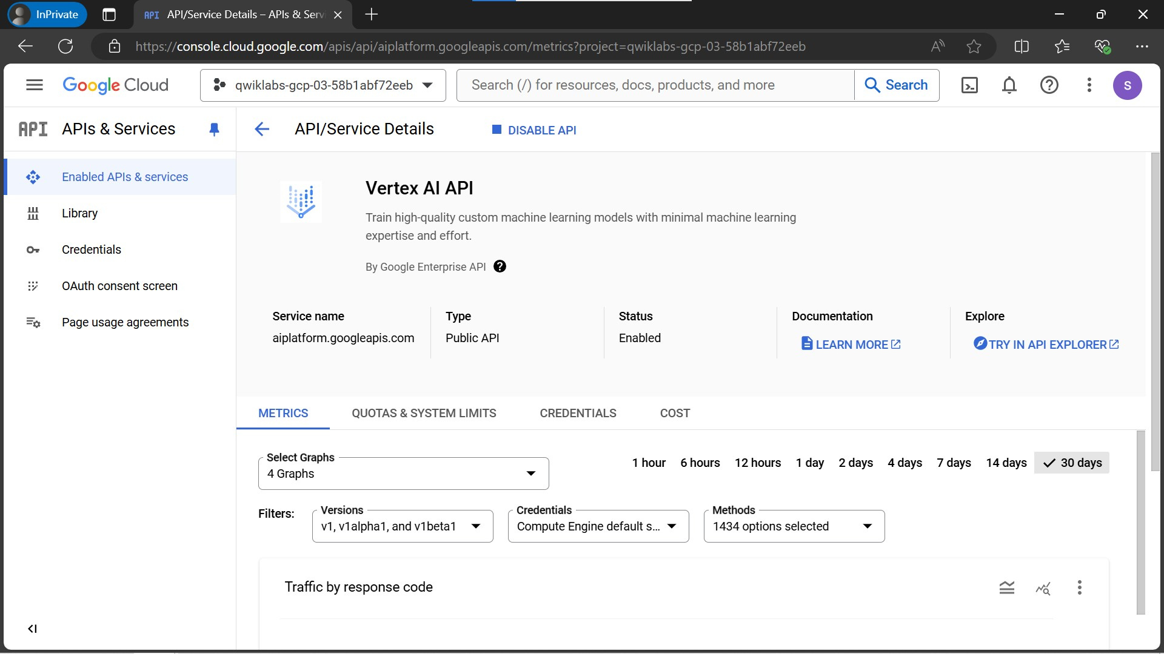

|  |  |
| --- | --- |
| **Prompt Design** |  |

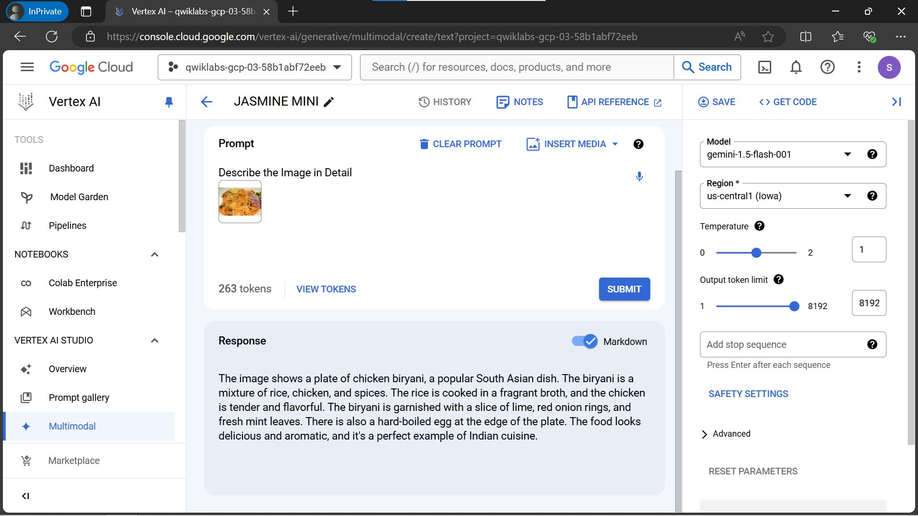

|  |  |
| --- | --- |
| **Jasmine’s Suggestions** |  |

